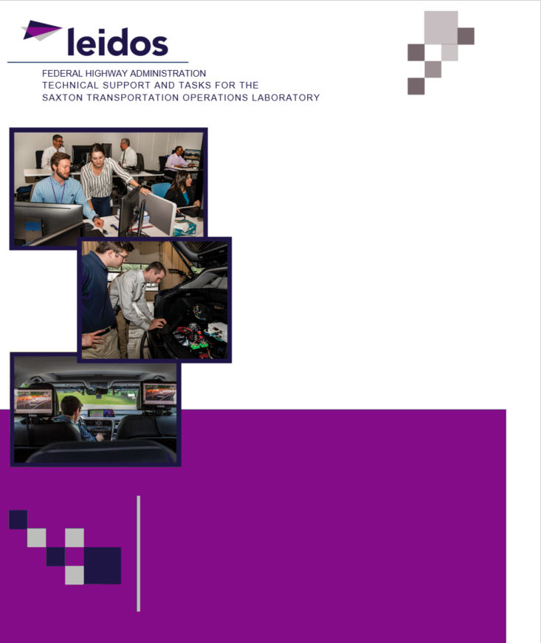

**Task Order: 22**

**March 21, 2020**

**Developing Analysis, Modeling, and Simulation (AMS) Tools for Connected and Automated Vehicle (CAV) Applications**

**Algorithm Description Document: A Lane Changing (LC) Model for Light Duty Connected and Automated Vehicles (CAVs)**

SI Conversion Chart. See https://www.fhwa.dot.gov/publications/convtabl.cfm for html version.

Table of Contents

Executive Summary 1

Chapter 1. PURPOSE OF THIS MODEL 3

Purpose of this document 3

Purpose of this Model 3

Document overview 4

Chapter 2. Model development and Logic 5

Description of model logic 5

Connected Autonomous Vehicle States 5

Connected Autonomous Vehicle Car-following 6

Connected Autonomous Vehicle Lane-changing 8

Model development 9

Connected Autonomous Vehicle Car Following Model 9

Connected Autonomous Vehicle Lane Changing 10

Chapter 3. MODEL CALIBRATION AND VALIDATION 15

Model calibration 15

Model validation 21

chapter 4. Basic Guidance on Model Implementation 27

chapter 5. Use case 29

Implementation of the developed model into a traffic simulation tool 29

Design of simulation experiments 30

Simulation results for the different scenarios 32

Chapter 6. SUMMARY AND RECOMMENDATIONS 37

Acknowledgments 39

BIBLIOGRAPHY 41

Appendix – Pseudocode 43

Main program 43

functions 43

List of Figures

Figure 1. Flow chart. The logic of the proposed model. 5

Figure 2. Illustration. Vehicle states. 6

Figure 3. Illustration. Connected autonomous vehicle car following path. 7

Figure 4. Illustration. Uncooperative/cooperative connected autonomous vehicle. 7

Figure 5. Illustration. Incentive and safety checks. 9

Figure 6. Equation. Linear adaptive cruise control model. 9

Figure 7. Equation. Incentive check. 10

Figure 8. Equation. Gipps’ safe distance. 10

Figure 9. Equation. Target acceleration calculated by IDM model. 11

Figure 10. Equation. A sin-function based lane changing path. 12

Figure 11. Equation. A linear function lane changing path. 12

Figure 12. Illustration. The connected autonomous vehicle lane changing/lane changing abortion path. 13

Figure 13. Illustration. Car following of lane changing. 13

Figure 14. Illustration. Car following of lane changing abortion. 14

Figure 15. Flow chart. Connected autonomous vehicle mandatory lane changing logic with key parameters. 15

Figure 16. Photo. Bird view of the field experiment. 16

Figure 17. Equation. Root mean square error of the connected autonomous vehicle space in model calibration. 16

Figure 18. Equation. The error between the calibrated lane changing time point and field observed lane changing time point in model calibration. 17

Figure 19. Equation. The calibration optimization objective. 17

Figure 20. Graph. Objective function convergence. 18

Figure 21. Graph. Calibration results of case 1. 19

Figure 22. Graph. Calibration results of case 2. 20

Figure 23. Graph. Calibration results of case 3. 20

Figure 24. Graph. Calibration results of case 4. 21

Figure 25. Equation. Root mean square error of the connected and automated vehicle space and speed in model validation. 21

Figure 26. Graph. Validation results of case 1. 23

Figure 27. Graph. Validation results of case 2. 24

Figure 28. Graph. Validation results of case 3. 25

Figure 29. Graph. Validation results of case 4. 26

Figure 30. Illustration. The mixed traffic simulation model implementation. 27

Figure 31. Screen shot. Study road segment (PTV Group 2018). 29

Figure 32. Equation. The connected autonomous vehicle average speed. 30

Figure 33. Equation. The connected autonomous vehicle speed standard deviation. 30

Figure 34. Equation. The human driven vehicle average speed. 31

Figure 35. Equation. The human driven vehicle speed standard deviation. 31

Figure 36. Equation. The average speed across all vehicles. 31

Figure 37. Equation. The speed standard deviation across all vehicles. 32

List of Tables

Table 1. Calibration results summary. 18

Table 2. Parameters calibration results. 18

Table 3. Validation results summary. 22

Table 4. Sensitivity analysis on connected and automated vehicle penetration rate. 32

Table 5. Sensitivity analysis on connected and automated vehicle cooperation rate. 34

Table 6. Sensitivity analysis on incentive check threshold. 34

Table 7. Sensitivity analysis on incentive check bias. 35

List of Abbreviations

CAV Connected and Autonomous Vehicle

USDOT United States Department of Transportation

AMS Analysis, Modeling, and Simulation

FHWA Federal Highway Administration

LC Lane Changing

SH Speed Harmonization

CM Coordinated Merge

CACC Cooperative Adaptive Cruise Control

ACC Adaptive Cruise Control

HV Human Driven Vehicle

CF Car Following

IDM Intelligent Driver Model

RMSE Root Mean Square Error

STD Speed Standard Deviation

Executive Summary

This document proposes a mixed traffic simulation model consisting of connected and automated vehicle (CAV) car-following (CF) and lane-changing (LC) controls that fully consider the dynamics of surrounding vehicles and handle different mixed traffic scenarios. The model is calibrated and validated using field data from the CAV mandatory LC model (a component of the mix traffic simulation model) obtained through small-scale field tests with three human driven vehicles (HVs) as surrounding vehicles. The proposed mixed traffic simulation model can be implemented into existing simulators, providing users an opportunity to investigate the impacts of CAV LC and CF on traffic systems and improving the fidelity of CAV simulation. A use case is conducted on the I-75 roadway segment in PTV VISSIM where the mixed traffic simulation model is used to control CAVs and the PTV VISSIM default vehicle control rules are used to control HVs. Sensitivity analyses on model key parameters are conducted and the results shed insights into understanding mixed traffic and provide basic guidance for engineering practice. This document is also expected to help future users easily adopt and customize this model in a traffic simulation tool they preferred to meet their simulation needs. To this end, Pseudocode of this model was included in the appendix.

Chapter 1. PURPOSE OF THIS MODEL

Purpose of this document

Connected autonomous vehicle (CAV) technologies offer potentially transformative societal impacts, including significant mobility, safety, and environmental benefits. The United States Department of Transportation (USDOT) has led the development, research, and standards making to support these technologies and is currently developing deployment and implementation approaches and guidelines.

In order for CAV applications to be deployed, state and local transportation agencies must first be able to effectively and fully quantify the impacts of such deployments and identify which application best addresses their unique transportation problem. Traffic analysis, modeling, and simulation (AMS) tools provide an efficient means to evaluate transportation improvement projects prior to deployment. Current AMS tools are not well-suited for evaluating CAV applications due to their inability to incorporate vehicle connectivity/communication and automated driving features. To mitigate this gap, Federal Highway Administration (FHWA) has sponsored this project to develop CAV applications/models based on field data to support CAV simulation community. Three CAV applications were developed under this project. They are a lane changing (LC) model for light duty CAVs, a combined application model that integrates speed harmonization (SH) and coordinated merge (CM), and an improved cooperative adaptive cruise control (CACC) model for light duty CAVs.

This document presents a LC model for light duty CAVs in detail. The objective of this document is to provide detailed information of this model to improve CAV simulation community. This document is expected to help future users easily adopt and customize this model in a traffic simulation tool they preferred to meet their simulation needs. To this end, this document describes the algorithms/logics of this model in detail. It also illustrates how this model was developed, calibrated, and validated. Pseudocode of this model was included in the appendix.

Purpose of this Model

CAV technologies can significantly improve traffic safety and reduce traffic congestion. Longitude control (e.g., adaptive cruise control (ACC)) has been already implemented in level-1 CAVs in commercial vehicles (Xiao and Gao 2010; Gunter et al. 2019). Latitude control (e.g., LC control) is one of the fundamental leaps from level-1 to level-2 and above CAVs.

Existing studies of LC control are limited in static motion planning without considering uncontrollable and dynamic surrounding human driven vehicles (HVs) in a mixed traffic environment (B. Li et al. 2018; Xu et al. 2012). Motion planning and LC decision are separately studied in a static setting. However, these two components shall be interdependent in real-world driving. Vehicle motions may change dynamically and consequentially affect the LC decision.

Motivated by the above research gap, this research proposes a new mixed traffic simulation framework that contains vehicle car following (CF) and LC movements and fully considers the dynamics of surrounding vehicles and handles different mixed traffic scenarios. The model can be implemented into existing traffic simulators enabling users to investigate CAV LC and CF behavior impacts on traffic systems under mixed traffic conditions, which improves the fidelity of CAV simulation. The model framework consists both HV and CAV control components. Any customized HVs CF and LC rules (e.g., the intelligent driver model (Treiber, Hennecke, and Helbing 2000) and Newell’s CF model (Newell 2002)) can be implemented into the simulation model to control HVs per application need which is not within the scope of this study. Recent studies on HVs’ responses to AVs w CAVs with and without differentiable appearance can be referred in constructing HV models (Zhao et al. 2020; Hamdar et al. 2019). As for the objective of this study, i.e., CAVs control component, a dynamic CAV LC model incorporating human driver behavior in mixed traffic is proposed (Wang et al., n.d.), which includes three key components: CF, LC decision making and LC/LC abortion path generation and following. A linearized ACC CF model (Milanés and Shladover 2014) is used to control CAV longitudinal movements through the whole process. LC decisions are differently defined for mandatory LCs and discretionary LCs. Both incentive check and safety check need to pass for a CAV to conduct a discretionary LC, yet only safety check is needed for a mandatory LC. Note that the necessary LC decision checks are checked throughout a LC process. A LC will be aborted whenever the safety check fails to pass before CAV passes the lane marking. The abortion mechanism guarantees LC safety. After the required checks pass, a sine-function based LC trajectory is dynamically generated and undated at each time step to regulate a smooth LC path (Wang et al., n.d.).

Field data from the CAV mandatory LC model (a component of the mixed traffic simulation model) is obtained through small-scale field experiments (Wang et al., n.d.) with three HVs as surrounding vehicles. Then the small-scale simulation experiments with the same settings as the field experiments are conducted to illustrate how to calibrate and validate the corresponding simulation component. A portion of the field data is used to calibrate the model parameters in the simulation experiments. The rest of the data is used for validation. Further, a large-scale simulation case study implementing the whole proposed mixed traffic simulation model is conducted in PTV VISSIM on an I-75 freeway segment to test the impacts of CAV LC configurations on traffic performance through sensitivity analyses on key parameters. The calibrated parameters from the field data are used in the large-scale case study. Note that in the case study, a linear LC path is used to replace the sine-function based LC path for simulation efficiency.

Document overview

Chapter 2 presents the mixed traffic simulation model logic and its development. Chapter 3 describes the model calibration and validation using field experiments data. Chapter 4 introduces the basic guidance on the model implementation to which future uses can refer whiling implementing the mixed traffic simulation model into existing simulators. Chapter 5 uses PTV VISSIM as an example to implement the proposed model and conducts sensibility analyses on key parameters to test the impacts of the model on traffic performance. Chapter 6 concludes this study and gives possible future research directions.

Chapter 2. Model development and Logic

Description of model logic

This section briefly introduces the proposed mixed traffic simulation model. The proposed model can fully control both human driven vehicles (HVs) and connected autonomous vehicles (CAVs) in the mixed traffic. A vehicle set *N* is defined containing *N* vehicles indexed by *n* ϵ {1,2,…,*N*}. Each vehicle is initialized with its type (i.e., HV or CAV) and route (i.e., origin and destination). For CAVs, their cooperation states are also defined indicating whether they will be cooperative to CAV LCs on an adjacent lane(s) or not. For the HV control component, customized HV car following (CF) and LC strategies can be implemented according to the application needs. Please refer to recent studies on HVs’ responses to AVs w CAVs with and without differentiable appearance for HV behavior modeling in mixed traffic (Zhao et al. 2020; Hamdar et al. 2019). This study mainly focuses on the CAV control component as highlighted in Figure 1. The proposed model is developed based on field experiments of a CAV mandatory LC model with three surrounding HVs in a previous study (Wang et al., n.d.).

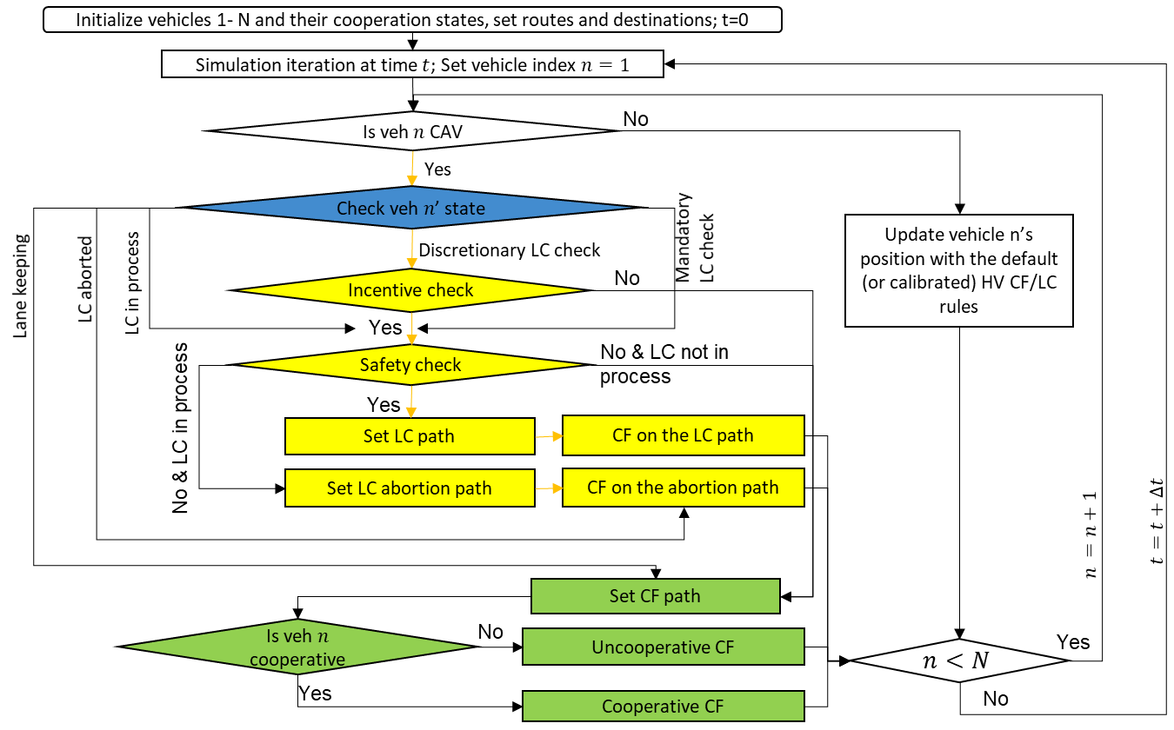

Source: FHWA.

Figure 1. Flow chart. The logic of the proposed model.

Connected Autonomous Vehicle States

At simulation time *t*, CAV *n*'s possible states are listed as follow:

* **Mandatory LC Check**: CAV *n* has to change to a specific lane for reaching its destination. For example, CAVs “R” on the middle lane within the mandatory LC zone in Figure 2.
* **Discretionary LC Check**: CAV *n* can stay on any one of multiple lanes. For example, CAV “R” outside of the mandatory LC zone and CAVs “T” in Figure 2.
* **Lane keeping**: CAV *n* has to stay on the same lane to reach the destination or due to the regulation (e.g., solid markings). For example, CAV “R” on the right lane within the mandatory LC zone.
* **LC in process**: CAV *n* has already initiated the LC movements. For example, the highlighted CAV “R” with the red solid circle in Figure 2.
* **LC aborted**: A CAV just aborted the LC to come back to the current lane. For example, the highlighted CAV “T” with the red dashed circle in Figure 2.

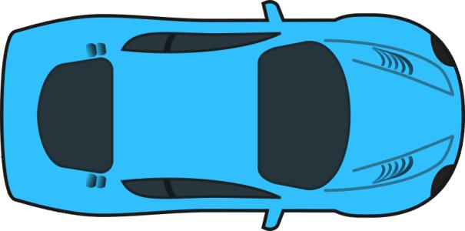

T



T



R



Mandatory LC zone for R turn traffic



T



R



T

R

R

T

R

R

: HV or CAV T: through vehicle

: CAV R: right turn vehicle



CAV

CAV

CAV

CAV

CAV

CAV

CAV

HV

HV

HV

HV

Source: FHWA.

Figure 2. Illustration. Vehicle states.

Connected Autonomous Vehicle Car-following

As shown in Figure 3, the center line of the lane is set as CAV CF path (i.e., the red dashed line). At simulation time *t*, CAV *n*’s CF behavior is defined based on its cooperative state initialization.



CAV

Current lane

Target lane

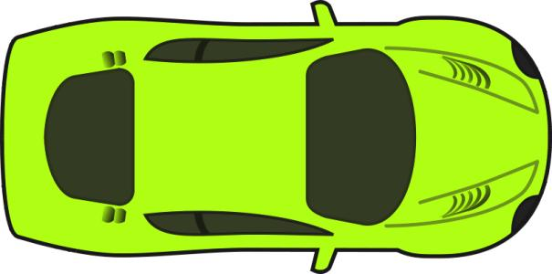

1



3



2

Veh 1,2 and 3: CAV or HV

Source: FHWA.

Figure 3. Illustration. Connected autonomous vehicle car following path.

1



2

Current lane

Target lane



3

1



CAV

Veh 1and 3: CAV or HV

Veh 2: CAV

1

Current lane

Target lane



CAV



1



2



3

Veh 1and 3: CAV or HV

Veh 2: CAV

Source: FHWA. Source: FHWA.

A. Uncooperative CAV. B. Cooperative CAV.

Figure 4. Illustration. Uncooperative/cooperative connected autonomous vehicle.

The CAV cooperative states are defined as follow:

* **CAV *n* uncooperative**: CAV $n$ only follows the preceding vehicle on the current lane regardless of the LC signal of the preceding CAV(s) on the neighboring lane(s), shown in Figure 4 A.
* **CAV *n* cooperative**: CAV *n* follows not only the preceding vehicle on the current lane but also the preceding CAV(s) on the neighboring lane(s) with the LC signal on, shown in Figure 4 B.

Connected Autonomous Vehicle Lane-changing

At simulation time $t,$ CAV $n$’s LC behavior contains two components: LC decision making and LC path generation and following/LC abortion path generation and following.

Lane Changing Decision Making

LCs are divided into two categories: discretionary LCs and mandatory LCs. Discretionary LCs take place when vehicles want to make a LC to improve its mobility. Mandatory LCs are implemented when vehicles need to reach their desired destinations. The corresponding LC decision checks are defined as follow:

* **Lane marking check**: Before any LC behavior, CAV *n* needs to check the current lane marking. The following checks will be exanimated only when the lane marking is dashed, indicating LC behavior is permitted. Otherwise, CAV $n$ is not allowed to make LC now.
* **Incentive check**: Defined only for discretionary LCs. It asks whether CAV *n* can travel faster by conducting a LC to follow a vehicle on the target lane (i.e., vehicle 2 in Figure 5 (a)). If yes, the incentive check passes.
* **Safety check**: Defined for both discretionary LCs and mandatory LCs. It asks whether CAV *n*'s deceleration induced by following the preceding vehicle on the target lane (i.e., vehicle 2 in Figure 5 (b)) is greater than a safety/comfort deceleration threshold or not, and whether the deceleration of the following vehicle on the target lane (i.e., vehicle 3 in Figure 5 (b)) induced by CAV *n*'s LC is greater than a safety/comfort deceleration threshold? If both are yes, the safety check passes.

17



1



2



CAV



3

Current lane

Target lane

Veh 1,2 and 3: CAV or HV

18



1



2



CAV



3

Current lane

Target lane

Veh 1,2 and 3: CAV or HV

Source: FHWA. Source: FHWA.

A. Incentive check. B. Safety check.

Figure 5. Illustration. Incentive and safety checks.

Lane Changing Path Generation and Following/Lane Changing Abortion Path Generation and Following

If both incentive check and safety check pass for CAV *n*'s discretionary LC or the safety check passes for CAV *n'*s mandatory LC, a LC path will be generated and followed. CAV *n* will follow both the preceding vehicle on the current lane and the preceding vehicle on the target lane during the LC process. Note that the safety check will be checked throughout the LC process. A LC abortion path will be generated and followed once the safety check failed to pass before CAV passes the lane marking. This means CAV *n* will go back to its original lane and only follows the preceding vehicle on the current lane to guarantee safety.

Model development

Connected Autonomous Vehicle Car Following Model

A linear Adaptive Cruise Control (ACC) model (Milanés and Shladover, 2014) is used to control CAVs longitudinal movements.



Figure 6. Equation. Linear adaptive cruise control model.

Where:

*K*1, *K*2=the parameters of the linearized car-following model.

$g_{CAV}$ = the desired time gap of the CAV.

*C* = the length of vehicle (CAV and HV).

$x_{CAV}\left(t\right)$ = the longitude position of the center point of the front bumper of the CAV at time $t$.

*v*CAV(*t*)= the speed of the CAV at time $t$.

*ã*CAV(*t*)= the final target acceleration of the CAV.

*x*1(*t*)= the longitude position of the preceding vehicle on the same lane.

*𝑣*1(*t*)= the speed of the preceding vehicle on the current lane.

Connected Autonomous Vehicle Lane Changing

Lane Changing Decision Making

Firstly, the lane marking type between the current and target lanes is checked to verify LC is permitted or not. Usually, dash-line markings indicate lane changing is permitted and drivers are not expected to change lane when lane markings are solid lines. If the marking type is dashed, the marking check passes. Otherwise, CAV continues lane keeping.

Secondly, the incentive check is required for CAV discretionary LCs.



Figure 7. Equation. Incentive check.

Where:

*ã*CAV(*t*)= the target acceleration of the CAV on the current lane.

*â*CAV(*t*)= the target acceleration of the CAV on the target lane.

Δ*a* = the changing threshold, preventing LCs when the associated advantage is marginal.

*a*bias = the asymmetry term with positive value for left turn and negative value for right turn (Treiber and Kesting 2013), guaranteeing the keep-right directive rule.

Thirdly, the safety check is required for both CAV discretionary and mandatory LCs. The safety check consists two checks with respecting to the preceding and following vehicles on the target lane respectively as demonstrated in Figure 5.

The first check is to check the distance between CAV position and the preceding vehicle position on the target lane when the LC is finished. $S\left(t\right)$ is the expected minimum safety distance calculated by Gipps’ safe distance algorithm (Gipps 1981), shown in Figure 12.



Figure 8. Equation. Gipps’ safe distance.

Where:

*τ*CAV = the reaction time of the CAV.

*b*CAV = the maximum deceleration of the CAV.

*v̂l*(*t*) = the speed of the preceding vehicle at time *t* on the target lane.

(*t*)*b̂l* = the maximum deceleration of the preceding vehicle on the target lane.

If *x̂l*(*t*) – *x*CAV(*t*) – *C* ≥ *S*(*t*), where *x̂l*(*t*) is the longitude position of the preceding vehicle at time *t* on the target lane, the CAV LC will not cause too dramatic deceleration to the CAV, and hence the safety check with respect to the preceding vehicle on the target lane passes.

The second check is for the following vehicle on the target lane. Intelligent driver model (IDM) is used to calculate the target acceleration of the following vehicle on the target lane *âf* (*t*) (Treiber and Kesting 2013; Treiber, Hennecke, and Helbing 2000).



Figure 9. Equation. Target acceleration calculated by IDM model.

Where:

*S*0 = the minimum gap.

ΔT = the time gap.

*δ =* the acceleration exponent.

*ŵf* = the maximum acceleration of the following vehicle on the target lane.

*x̂f*(*t*) = the longitude position of the following vehicle on the target lane.

*v̂f*(*t*) = the speed of the following vehicle on the target lane.

*b̂f* = the maximum deceleration of the following vehicle on the target lane.

If *âf* (*t*) ≥ *b̂f*, the CAV LC maneuver will not cause too dramatic deceleration to the following vehicle on the target lane, and hence the safety check concerning the following vehicle on the target lane passes.

Lane Changing Path Generation And Following /Lane Changing Abortion Path Generation And Following

After all checks pass, a smooth 2-D spatial LC path will be generated and updated at each time step for the CAV to follow and complete the LC reaching its final target position obtained with Figure 8 safely and comfortably.

A sine-function based LC path (i.e., the black dotted curve in Figure 12) is applied to generate a smooth trajectory at time *t* composed of discrete points (*x*´AV, *y*´AV) in the local coordinate system, formulated as:







Figure 10. Equation. A sin-function based lane changing path.

Where:

*x*CAV(*t*), *y*CAV(*t*) = the longitudinal and latitudinal positions of the CAV at current time .

*x*2(*t*), *y*2(*t*) = the longitudinal and latitudinal positions of vehicle 2 in Figure 12 at current time *t*.

*S*(*t*) = the safety distance calculated in Figure 8. *X*CAV

*C* = the vehicle length, which is set as the same for all vehicles.

*R*X(*t*), *R*Y(*t*) = the longitudinal gap and the lateral offset between the CAV and vehicle 2 at current time *t*.

In the large-scale simulation, a linear function LC path (i.e., the red solid line in Figure 12) is used to replace the sine-function based LC path (i.e., the black dotted curve in Figure 12) for simplicity, formulated as follows:



Figure 11. Equation. A linear function lane changing path.

The safety check is continuously checked throughout the LC process. The CAV LC will be aborted once the safety check fails to pass. A LC abortion path (i.e., the green dashed line in Figure 12), symmetric to the LC path, will be generated and followed. The CAV will go back to its original lane and follow the preceding vehicle. With the LC abortion mechanism, CAV LC safety can be guaranteed.

Current lane

Target lane



CAV

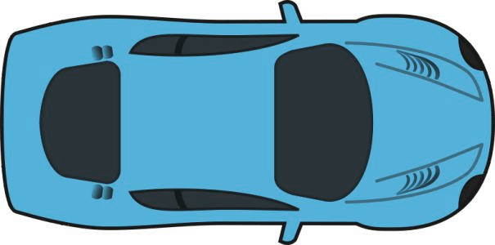

**CAV**



2



3



1



1



2



3

Veh 1,2 and 3: CAV or HV

*Y*

*X*

$$S(t)$$

Source: FHWA.

Figure 12. Illustration. The connected autonomous vehicle lane changing/lane changing abortion path.

During the LC process, the CAV uses the ACC model to follow the preceding vehicles on the current and target lanes (i.e., vehicle 1 and 2 in Figure 13 A) before it passes the lane markings. After CAV passes the lane markings, it only follows the current preceding vehicle (i.e., vehicle 2 in Figure 13 B) using the ACC model.



2

Current lane

Target lane



3

1



CAV

Veh 1,2 and 3: CAV or HV

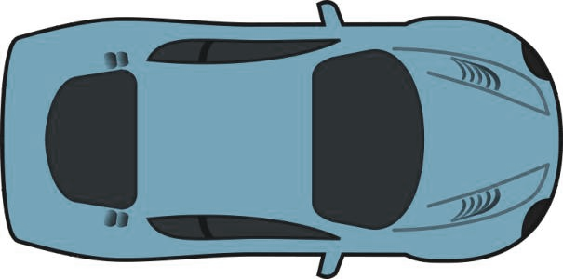

CAV



2

Current lane

Target lane



3

1



CAV

Veh 1,2 and 3: CAV or HV



CAV

Source: FHWA. Source: FHWA.

A. Car following before the lane marking. B. Car following after the lane marking.

Figure 13. Illustration. Car following of lane changing.

During the LC abortion process, the CAV uses the ACC model to follow the preceding vehicles on the current lane (i.e., vehicle 1 in Figure 14) and goes back to the center line of the lane.



2

Current lane

Target lane



3

1



CAV

Veh 1,2 and 3: CAV or HV



CAV



CAV

Source: FHWA.

Figure 14. Illustration. Car following of lane changing abortion.

Chapter 3. MODEL CALIBRATION AND VALIDATION

Model calibration

To demonstrate how to calibrate the above proposed model framework, this study uses the field data collected from small-scale field experiments of a connected and automated vehicle (CAV) mandatory lane changing (LC) model with three surrounding human driven vehicles (HVs) in a previous study (Wang et al., n.d.). The CAV mandatory LC model flow chart is presented in Figure 15. CAV in Figure 16 uses adaptive cruise control (ACC) model to follow HV 1 and 2 and keeps checking the safety check toward HV 2 and HV3. Once the safety check passes, a sine-function based LC path, i.e., Figure 10, will be generated for CAV to follow. The safety check will be continuously checked within the LC path following process and the LC maneuver will be aborted once the safety check fails to pass. If the safety check passes along the whole LC path following process, CAV LC is finished successfully.

Start

Car following (and lane keeping)

Path generation

CAV lane changing finished

Lane changing decision (safety check)

Path following and safety check loop

Yes

Yes

No

No

ACC model parameters: $K_{1},K_{2}$

CAV desired time gap: $g_{CAV}$

Safety Check Parameters:

1. Maximum deceleration of CAV: $b_{CAV}$
2. CAV reaction time: $τ_{CAV}$
3. Minimum car following gap in IDM: $s_{0}$
4. Acceleration exponent in IDM: $δ$
5. Time gap: $∆T$
6. Maximum deceleration of the preceding vehicle on the target lane: ${\hat{b}}_{l}$
7. Maximum acceleration of the following vehicle on the target lane: ${\hat{w}}_{f}$

Source: FHWA.

Figure 15. Flow chart. Connected autonomous vehicle mandatory lane changing logic with key parameters.

The test track segment is a two-lane straight road with length *L* = 800 m and lane width   
*D* = 3.5 m. Figure 16 shows the field experiment of the CAV mandatory LC with 3 surrounding HVs. All vehicles’ lengths are set as *C*= 4.6 m. The sine-function based LC path is implemented during the field experiments. Videos of the field experiments are available at <https://www.youtube.com/watch?v=34FubITFebI>. Sample data are available at <https://github.com/sgzzgit/Autonomous-Vehicle-Lane-Change-Experiment-Data>.

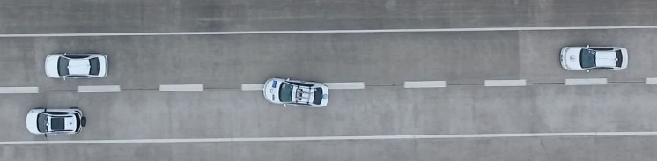

CAV

HV 1

HV 2

HV 3

Original photo: © 2019 Xiaopeng Li

(see Acknowledgements section).

Figure 16. Photo. Bird view of the field experiment.

Four cases (*c* ϵ {1,2,3,4}) of experiments representing different traffic situations are conducted. In the first case (*c* = 1), the preceding vehicle on the current lane (i.e., HV 1 in Figure 16) is required to decelerate, creating a shock wave on the current lane. The preceding vehicle on the target lane (i.e., HV 2 in Figure 16) keeps relatively constant speed and the following vehicle on the target lane (i.e., HV 3 in Figure 16) is not aggressive, yielding to the CAV LC. In the second case (*c* = 2), HV 2 is required to decelerate, creating a shock wave on the target lane. HV 1 keeps relatively constant speed and HV 3 is not aggressive, yielding to the CAV LC. In the third case (*c* = 3), HV 1 and 2 both keep relatively constant speed and HV 3 is still not aggressive, yielding to the CAV LC. In the last case (*c* = 4), HV 1 and 2 both keep relatively constant speed, but HV 3 is required to accelerate, not yielding to the CAV LC, which represents aggressive driving and results the CAV LC abortion. The speeds of HV 1 and HV 2 are kept within 10-45 km/h during the experiments (Wang et al., n.d.). Note that two runs experiments with the same settings are conducted for each case. The data of the first run of four cases is used for calibration and the second run data is used for validation.

Small-scale simulation with the same setting as the field experiments is conducted to calibrate the CAV mandatory LC model parameters (listed in Figure 15), a component of the mixed traffic simulation model. HV 1, 2 and 3 trajectories are controlled to replicate the field experiments trajectories and the CAV trajectory is generated using the proposed CAV LC model.

Root mean square error (RMSE) of the CAV space is formulated as:



Figure 17. Equation. Root mean square error of the connected autonomous vehicle space in model calibration.

Where:

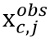,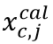 = the field observed and calibrated space of CAV at time point $j$ in case $c$ respectively.

*J*c = the total number of time points in case $c$.

β = the parameters set.

The error between the calibrated LC time point and field observed LC time point is formulated as:



Figure 18. Equation. The error between the calibrated lane changing time point and field observed lane changing time point in model calibration.

Where:

*tc LCobs*, *tc LCcal* = the field observed and calibrated LC time point in case $c$ respectively.

β = the parameters set.

Thus, the calibration optimization objective is formulated as:



Figure 19. Equation. The calibration optimization objective.

Where:

*RMSExc* = root mean square error of the CAV space in case *c*.

*Etc* = the error between the calibrated LC time point and field observed LC time point in case *c*.

β = the parameters set.

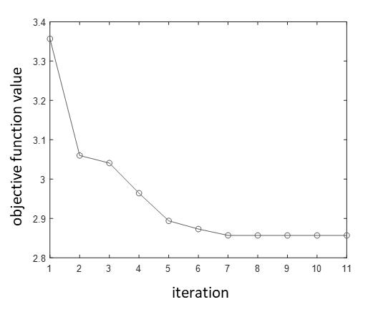

Source: FHWA.

Figure 20. Graph. Objective function convergence.

The interior-point method is used to find the optimal parameter values. The objective function convergence trend is plotted in Figure 20. The objective function value is stable at 2.86 after iteration 7 with an average *RMSExc* (*β*) of 1.46 m and an average *Etc*(*β*) of 1.4 s indicating a good calibration results, shown in Table 1. And the parameters *β* calibration results are provided in

|  |  |  |  |  |
| --- | --- | --- | --- | --- |
| Case | *tcLCobs* (s) | *tcLCcal* (s) | *Etc* (s) | *RMSExc*(m) |
| *c* = 1 | 36.2 | 39.0 | 2.8 | 1.86 |
| *c* = 2 | 11.5 | 13.4 | 1.9 | 1.06 |
| *c* = 3 | 30.2 | 31.1 | 0.9 | 0.92 |
| *c* = 4 | inf | inf | 0.0 | 1.99 |
| Average |  | | 1.4 | 1.46 |

Note:

Inf denotes no LC behavior.

*tcLCobs* denotes the field observed LC time point in case *c*.

*tcLCcal*denotes the calibrated LC time point in case *c*.

*Etc* denotes the error between the calibrated LC time point and field observed LC time point.

*RMSExc*denotes root mean square error of the CAV calibrated space.

Table 2. The detailed CAV space and LC time calibration results of four cases are provided in Figure 21 – Figure 24. The calibrated CAV trajectory (i.e., the dashed curve) is almost consistent with the field observed trajectory (i.e., the solid curve) with minor differences. And the difference between the calibrated and field observed LC time point is less than 3 s across all cases.

Table 1. Calibration results summary.

|  |  |  |  |  |
| --- | --- | --- | --- | --- |
| Case | *tc LCobs* (s) | *tc LCcal* (s) | *Etc* (s) | *RMSExc* (m) |
| *c* = 1 | 36.2 | 39.0 | 2.8 | 1.86 |
| *c* = 2 | 11.5 | 13.4 | 1.9 | 1.06 |
| *c* = 3 | 30.2 | 31.1 | 0.9 | 0.92 |
| *c* = 4 | inf | inf | 0.0 | 1.99 |
| Average |  | | 1.4 | 1.46 |

Note:

Inf denotes no LC behavior.

*tc LCobs* denotes the field observed LC time point in case *c*.

*tc LCcal*denotes the calibrated LC time point in case *c*.

*Etc* denotes the error between the calibrated LC time point and field observed LC time point.

*RMSExc* denotes root mean square error of the CAV calibrated space.

Table 2. Parameters calibration results.

|  |  |
| --- | --- |
| Parameters (*β*) | Calibration results |
| *K*1 (*s* –2) | 0.1997 |
| *K*2 (*s* –1) | 0.6820 |
| *g*CAV (*s*) | 1.5265 |
| *b*CAV (*m*/*s*2) | -4.5000 |
| *τ*CAV (*s*) | 0.9000 |
| *s*0 (*m*) | 4.0000 |
| *δ* | 2.0000 |
| Δ*T* (*s*) | 1.3000 |
| *b̂l* (*m*/*s*2) | -4.2000 |
| *ŵf* (*m*/*s*2) | 4.0000 |



Source: FHWA.

Figure 21. Graph. Calibration results of case 1.



Source: FHWA.

Figure 22. Graph. Calibration results of case 2.



Source: FHWA.

Figure 23. Graph. Calibration results of case 3.



Source: FHWA.

Figure 24. Graph. Calibration results of case 4.

Model validation

The second run data of the four cases is used for model validation. RMSE of CAV spaces *RMSExc* and speeds *RMSEvc* (m/s) are calculated for four cases using the calibrated parameters from the first run.



Figure 25. Equation. Root mean square error of the connected and automated vehicle space and speed in model validation.

Where:

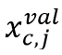,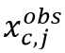= the field observed and calibrated speed of CAV at time point *j* in case *c* respectively.

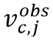,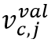= the field observed and calibrated speed of CAV at time point *j* in case *c* respectively.

*J*c = the total number of time points in case $c$.

β = the parameters set.

The validation results are summarized in Table 3. The error between the validated LC time and field observed LC time is only 0.53 s on average. *RMSExc* with an average value of 2.10 m and *RMSEvc* with an average value of 0.35 m/s. Compared with the calibration results (i.e., *RMSExc* with an average value of 1.46 m and the LC time error with an average value of 1.4 s), the validation results show less differences, which suggest an effective calibration. Detailed validation results are provided in Figure 26-Figure 29.

Table 3. Validation results summary.

|  |  |  |  |  |  |
| --- | --- | --- | --- | --- | --- |
| Case | *tcLCobs* (s) | *tcLCval* (s) | *Etc* (s) | *RMSExc* (m) | *RMSEvc* (m/s) |
| *c* = 1 | 53.6 | 53.8 | 0.2 | 1.55 | 0.25 |
| *c* = 2 | 26.0 | 26.2 | 0.6 | 1.87 | 0.44 |
| *c* = 3 | 21.3 | 22.6 | 1.3 | 1.87 | 0.32 |
| *c* = 4 | inf | inf | 0.0 | 3.12 | 0.38 |
| Average |  | | 0.53 | 2.10 | 0.35 |

Note:

Inf denotes no LC behavior.

*tcLCobs* denotes the field observed LC time point in case $c$.

*tcLCval* denotes the validated LC time point in case $c$.

*Etc* denotes the error between the validated LC time point and field observed LC time point.

*RMSExc* denotes root mean square error of the CAV validated space.

*RMSEvc* denotes root mean square error of the CAV validated speed.



Source: FHWA.

A. Vehicle space in case 1.



Source: FHWA.

B. Vehicle speed in case 1.

Figure 26. Graph. Validation results of case 1.



Source: FHWA.

A. Vehicle space in case 2.



Source: FHWA.

B. Vehicle speed in case 2.

Figure 27. Graph. Validation results of case 2.



Source: FHWA.

A. Vehicle space in case 3.



Source: FHWA.

B. Vehicle speed in case 3.

Figure 28. Graph. Validation results of case 3.



Source: FHWA.

A. Vehicle space in case 4.



Source: FHWA.

B. Vehicle speed in case 4.

Figure 29. Graph. Validation results of case 4.

chapter 4. Basic Guidance on Model Implementation

To implement the proposed model into existing traffic simulators, the following modifications are needed:

* Create the customized roadway network according to the application needs.
* Set roadway throughput, label human driven vehicles (HVs) and connected and automated vehicles (CAVs), define CAV cooperation states and initialize CAV and HV routes (i.e., origins and destinations) as well as desired speeds in the demand loading module.
* Replace the simulators default vehicle car following (CF) and lane changing (LC) rules with the proposed CAV CF and LC rules for CAV control in the vehicle dynamic module.

Note that the simulators default vehicle control rules can still be used for HV control.

Figure 30 provides a demonstration. There are a three-lane main road, a single lane on-ramp and a single lane off-ramp. Traffic stream moves from left to right with mainline throughput *q*1 and on-ramp throughput *q2*. CAV penetration rates *r*1CAV and *r*2CAV, CAV diverging rates (i.e., right turn rates) 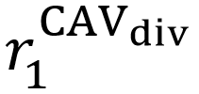 and 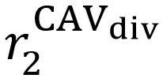 and HV diverging rates 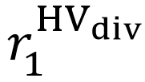 and 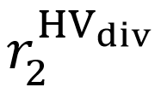 are defined for mainline and on-ramp respectively. CAV cooperative rate is defined as φ, denoting the percentage of cooperative CAVs. Vehicles will be randomly generated based on these predefined parameters.



Zone A

Zone B

Lane 1

Lane 2

Lane 3

off-ramp

on-ramp

Mainline throughput

On-ramp throughput

Simulation segment

T

T

T

R

T

R

R

R

R

R

T

T

T

T

T

T

T

T

T



: HV T: through vehicle

: CAV R: right turn vehicle

$$l^{th}$$

HV

HV

HV

HV

HV

HV

HV

HV

HV

HV

HV

CAV

HV

CAV

CAV

CAV

CAV

CAV

CAV

Source: FHWA.

Figure 30. Illustration. The mixed traffic simulation model implementation.

Two mandatory LC zones (i.e., zone A and zone B), shadowed in Figure 30, are defined for this demonstration segment because the needs of on-ramp merging and off-ramp diverging. Zone A with a length of *L*A defines the mandatory LC area that on-ramp CAVs have to merge into the main lanes. And zone B with a length of *L*B defines the mandatory LC area that right turn CAVs have to reach the right-most lane to exit the freeway through the off-ramp. The other areas are the CAV discretionary LC area. Note that the existing of the two mandatory LC zones should vary per application needs. If there is no on-ramp, zone A is not needed. If there is no off-ramp, zone B is not needed. If there is no ramp at all, neither zone is needed.

chapter 5. Use case

Implementation of the developed model into a traffic simulation tool

PTV VISSIM is used to implement the mixed traffic simulation model on the I-75 highway segment, located in Tampa Florida as shown in Figure 31. The program is coded in C++ programming language in Microsoft Visual Studio integrated development environment to generate the external “DriverModel.DLL”, which is used for CAV control in PTV VISSIM. The Calibration parameters (see Note:

Inf denotes no LC behavior.

*tcLCobs* denotes the field observed LC time point in case *c*.

*tcLCcal*denotes the calibrated LC time point in case *c*.

*Etc* denotes the error between the calibrated LC time point and field observed LC time point.

*RMSExc*denotes root mean square error of the CAV calibrated space.

Table 2) are used in the simulation.

* The selected roadway segment created in PTV VISSIM is about 6,000 meters long with three main lanes and a single lane on-ramp as well as a single lane off-ramp, shown in Figure 31. Zone A length *L*A and Zone B length *L*B are set as 300 m and 1400 m, respectively.

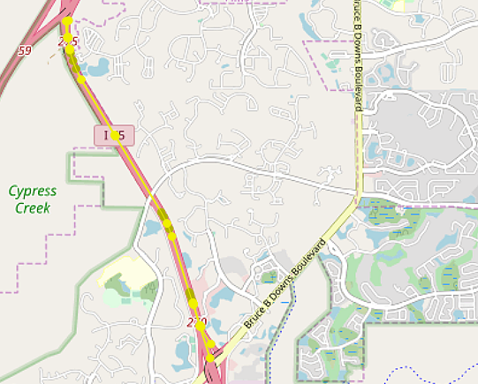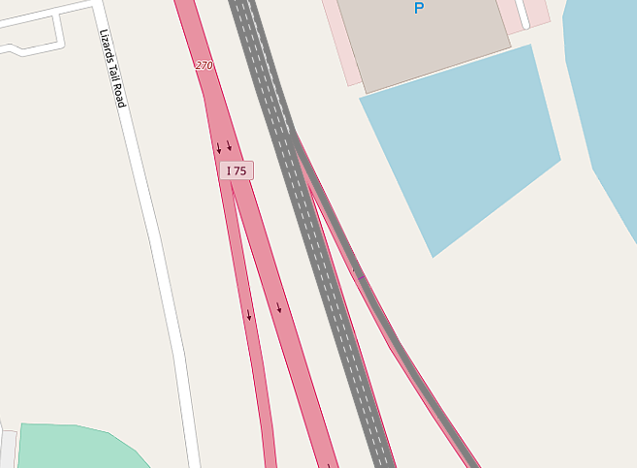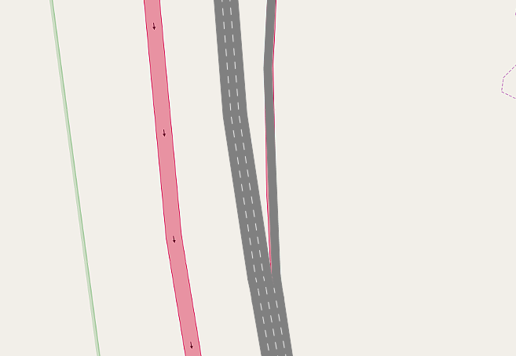

on-ramp

off-ramp

6,000 meters

Source: Screen shot created by FHWA using PTV VISSIM. PTV VISSIM

is the intellectual property of PTV Group and is used herein under the license.

Figure 31. Screen shot. Study road segment (PTV Group 2018).

* In the simulation default case, mainline and on-ramp throughputs $q_{1}$ and $q_{2}$ are set as 4500 vehicle/h and 1200 vehicle/h to simulated congested traffic. Connected autonomous vehicle (CAV) diverging rates  and  are set as 0.2 for the mainline and on-ramp traffic, human driven vehicle (HV) diverging rates  and  are set as 0.2 for the mainline and on-ramp traffic, CAV penetration rates *r*1CAV and *r*2CAV are set as 0.5 for the mainline and on-ramp traffic, CAV cooperation rate φ is set as 0.5, and incentive check threshold Δ*a* and bias *abias* are set as 0.1 m/s2 and 0.3 m/s2, respectively. Vehicles are randomly generated based on these parameters with their desired speeds around 30 m/s on the mainline and 25 m/s on the on-ramp. The simulation duration is set as 5 min in default with 0.1 s as the time step.
* CAVs are controlled through an external “DriverModel.dll” that implements the proposed model and HVs are control using the PTV VISSIM default car following (CF)/lane changing (LC) rules (PTV Group 2018).

Design of simulation experiments

Sensitivity analyses are conducted on key parameters *r*1CAV , *r*2CAV, φ, Δ*a*, and *abias* with one of the key parameters changed and other parameters kept the same. Vehicle average speed and speed standard deviation along the study roadway segment are used to measure traffic mobility and stability performance, respectively.

Separate vehicle set *N* into CAV set *j* ϵ *J* = {1,…,*J*} and HV set *k* ϵ *K* = {1,…,*K*}. The CAV average speed *v̅*CAV in the simulation period is formulated as:



Figure 32. Equation. The connected autonomous vehicle average speed.

Where:

*Tj* = the number of time points that CAV *j* running during a simulation period.

*vj*(*t)* = CAV *j* speed at time point *t*.

*J* = the total number of CAVs.

The CAV speed standard deviation STD*v*CAV in the simulation period is formulated as:



Figure 33. Equation. The connected autonomous vehicle speed standard deviation.

Where:

*Tj* = the number of time points that CAV *j* running during a simulation period.

*vj*(*t)* = CAV *j* speed at time point *t*.

*v̂J* = the average speed of CAV *j* in the simulation period.

*J* = the total number of CAVs.

The HV average speed *v̅*HV in the simulation period is formulated as:



Figure 34. Equation. The human driven vehicle average speed.

Where:

*Tk* = the number of time points that HV *j* running during a simulation period.

*vk*(*t)* = HV *k* speed at time point *t*.

*K* = the total number of HVs.

The HV speed standard deviation STD*v*HV in the simulation period is formulated as:



Figure 35. Equation. The human driven vehicle speed standard deviation.

Where:

*Tk* = the number of time points that HV *k* running during a simulation period.

*vk*(*t)* = HV *k* speed at time point *t*.

*v̂k* = the average speed of HV *k* in the simulation period.

*K* = the total number of HVs.

The average speed across all vehicles ${\overline{v}}_{all}$ in the simulation period is formulated as:



Figure 36. Equation. The average speed across all vehicles.

Where:

*Tj* = the number of time points that CAV *j* running during a simulation period.

*vj*(*t)* = CAV *j* speed at time point *t*.

*J* = the total number of CAVs.

*Tk* = the number of time points that HV *j* running during a simulation period.

*vk*(*t)* = HV *k* speed at time point *t*.

*K* = the total number of HVs.

The speed standard deviation across all vehicles STD*v*all in the simulation period is formulated as:



Figure 37. Equation. The speed standard deviation across all vehicles.

Where:

*Tj* = the number of time points that CAV *j* running during a simulation period.

*vj*(*t)* = CAV *j* speed at time point *t*.

*v̂J* = the average speed of CAV *j* in the simulation period.

*J* = the total number of CAVs.

*Tk* =the number of time points that HV *k* running during a simulation period.

*vk*(*t)* = HV *k* speed at time point *t*.

*v̂k* = the average speed of HV *k* in the simulation period.

*K* = the total number of HVs

CAV, HV and total traffic throughput (*q*CAV, *q*HV, and *q*all) at the location where the red line located in Figure 30 during a 5-min simulation period is also measured, and *l*th is set as 500 m. Note that we set *r*1CAV = *r*2CAV = *r*CAV in the simulation, indicating that CAV penetration rates are the same in the mainline and on-ramp traffic.

Simulation results for the different scenarios

The average speed is used to indicate the mobility performance. The greater the average speed, the better the mobility. The speed standard deviation is used to measure the stability performance. The greater the speed standard deviation, the worse the stability performance. Vehicle throughput is another measurement of the mobility performance. The sensitivity analyses results are presented in Table 4 – Table 7.

Table 4. Sensitivity analysis on connected and automated vehicle penetration rate.

|  |  |  |  |  |  |  |
| --- | --- | --- | --- | --- | --- | --- |
|  | *r* CAV = 0 | *r* CAV = 0.1 | *r* CAV = 0.2 | *r* CAV = 0.5 | *r* CAV = 0.7 | *r* CAV = 1 |
| *v̅*CAV (m/s) | \ | 24.744 | 24.491 | 24.185 | 18.435 | 17.372 |
| STD*v*CAV (m/s) | \ | 2.104 | 2.749 | 1.983 | 4.913 | 4.131 |
| *v̅*HV (m/s) | 26.471 | 26.115 | 25.399 | 24.858 | 20.082 | \ |
| STD*v*HV (m/s) | 2.150 | 2.584 | 3.441 | 2.105 | 5.445 | \ |
| *v̅*all (m/s) | 26.471 | 25.996 | 25.227 | 24.514 | 18.928 | 17.372 |
| STD*v*all (m/s) | 2.150 | 2.5421 | 3.310 | 2.043 | 5.072 | 4.131 |
| *q*CAV (CAVs/5 min) | \ | 23 | 56 | 146 | 153 | 203 |
| *q*HV (HVs/5 min) | 325 | 298 | 263 | 160 | 76 | \ |
| *qall* (vehicles/5 min) | 325 | 321 | 319 | 306 | 229 | 203 |

Note:

*r* CAV denotes CAV penetration rate.

*v̅*CAV denotes CAV average speed in the simulation period.

STD*v*CAV denotes CAV speed standard deviation in the simulation period.

*v̅*HV denotes HV average speed in the simulation period.

STD*v*HV denotes HV speed standard deviation in the simulation period.

STD*v*all denotes CAV and HV speed standard deviation.

*v̅*all denotes CAV and HV average speed.

*q*CAV denotes the CAV throughput in 5 min.

*q*HV denotes the HV throughput in 5 min.

*qall* denotes all vehicle throughput in 5 min.

The results in Where:

*Tj* = the number of time points that CAV *j* running during a simulation period.

*vj*(*t)* = CAV *j* speed at time point *t*.

*v̂J* = the average speed of CAV *j* in the simulation period.

*J* = the total number of CAVs.

*Tk* =the number of time points that HV *k* running during a simulation period.

*vk*(*t)* = HV *k* speed at time point *t*.

*v̂k* = the average speed of HV *k* in the simulation period.

*K* = the total number of HVs

CAV, HV and total traffic throughput (*qCAV*, *qHV*, and *qall*) at the location where the red line located in Figure 30 during a 5-min simulation period is also measured, and *lth* is set as 500 m. Note that we set *r1CAV* = *r2CAV* = *rCAV* in the simulation, indicating that CAV penetration rates are the same in the mainline and on-ramp traffic.

Simulation results for the different scenarios

The average speed is used to indicate the mobility performance. The greater the average speed, the better the mobility. The speed standard deviation is used to measure the stability performance. The greater the speed standard deviation, the worse the stability performance. Vehicle throughput is another measurement of the mobility performance. The sensitivity analyses results are presented in Table 4 – Table 7.

Table 4 show that as the CAV penetration rate *r* CAV increases, CAV mobility (*v̅*CAV), HV mobility *v̅*HV and overall mobility (*v̅*all, *qall*) decrease. The reason might be that more CAV LCs conducted when *r* CAV is greater causing more traffic oscillation and leading to worse mobility performance. Also, the calibrated CAV model drives more conservatively with a longer average headway than HVs, which aggravates the congestion. As *r* CAV increases, CAV, HV and overall stability (indicated by *v̅*CAV, *v̅*HV, and *v̅*all respectively) fluctuate. *r* CAV increase will result in more CAV LCs that cause more traffic oscillation and worse stability performance. Yet, as   
*r* CAV keeps increasing, more CAVs can be coordinated due to their cooperative behaviors, which will improve the stability performance. Note that the best CAV, HV, and overall stability performances are observed when *r* CAV = 0.5 indicating that under this case the proposed model is better than the PTV VISSIM vehicle control model in terms of the traffic stability. If the calibrated CAV model had a shorter time headway, we expect that both the mobility and stability performance would have improved with increasing *r* CAV.

Table 5. Sensitivity analysis on connected and automated vehicle cooperation rate.

|  |  |  |  |  |  |  |
| --- | --- | --- | --- | --- | --- | --- |
|  | 𝛗 = 0 | 𝛗 = 0.1 | 𝛗 = 0.2 | 𝛗 = 0.5 | 𝛗 = 0.7 | 𝛗 = 1 |
| *v̅*CAV (m/s) | 21.764 | 21.236 | 21.411 | 24.185 | 22.088 | 20.338 |
| STD*v*CAV (m/s) | 4.388 | 4.848 | 4.084 | 1.983 | 3.750 | 4.684 |
| *v̅*HV (m/s) | 23.544 | 22.933 | 24.127 | 24.858 | 23.224 | 22.340 |
| STD*v*HV (m/s) | 4.276 | 5.167 | 3.651 | 2.105 | 4.118 | 4.757 |
| *v̅*all (m/s) | 22.634 | 22.066 | 23.250 | 24.514 | 22.643 | 21.317 |
| STD*v*all (m/s) | 4.333 | 5.004 | 3.872 | 2.043 | 3.930 | 4.720 |
| *q*CAV (CAVs/5 min) | 132 | 131 | 138 | 146 | 138 | 126 |
| *q*HV (HVs/5 min) | 154 | 152 | 160 | 160 | 155 | 142 |
| *qall* (vehicles/5 min) | 286 | 283 | 298 | 306 | 293 | 268 |

Note:

φ denotes CAV cooperation rate.

*v̅*CAV denotes CAV average speed in the simulation period.

STD*v*CAV denotes CAV speed standard deviation in the simulation period.

*v̅*HV denotes HV average speed in the simulation period.

STD*v*HV denotes HV speed standard deviation in the simulation period.

STD*v*all denotes CAV and HV speed standard deviation.

*v̅*all denotes CAV and HV average speed.

*q*CAV denotes the CAV throughput in 5 min.

*q*HV denotes the HV throughput in 5 min.

*qall* denotes all vehicle throughput in 5 min.

Shown in Table 5, as CAV cooperation rate *φ* increases, the mobility and stability performance improve until *φ* = 0.5 and then degrades as *φ* further increases. As *φ* initially increases, more cooperative traffic increases chances of CAVs complete mandatory lane changes (MLCs) and discretionary lane changes (DLCs) more easily and the impedance from LCs is reduced. Thus, the traffic performance is improved. As *φ* further increases, more CAV cooperative and LC behaviors are observed, which increases the average gaps between vehicles, cause more traffic oscillation and thus slow down the traffic and lead to unstable traffic.

Table 6. Sensitivity analysis on incentive check threshold.

|  |  |  |  |  |  |
| --- | --- | --- | --- | --- | --- |
|  | 𝚫*a* = 0  **(m/s2)** | 𝚫*a* = 0.1  **(m/s2)** | 𝚫*a* = 0.2  **(m/s2)** | 𝚫*a* = 0.3  **(m/s2)** | 𝚫*a* = 0.4  **(m/s2)** |
| *v̅*CAV (m/s) | 21.971 | 24.185 | 23.066 | 22.660 | 23.039 |
| STD*v*CAV (m/s) | 4.067 | 1.983 | 3.011 | 3.595 | 3.652 |
| *v̅*HV (m/s) | 23.822 | 24.858 | 24.145 | 24.416 | 24.276 |
| STD*v*HV (m/s) | 3.948 | 2.105 | 3.078 | 3.330 | 3.736 |
| *v̅*all (m/s) | 22.876 | 24.514 | 23.594 | 23.518 | 23.644 |
| STD*v*all (m/s) | 4.009 | 2.043 | 3.044 | 3.465 | 3.693 |
| CAV throughput | 135 | 146 | 139 | 139 | 138 |
| HV throughput | 155 | 160 | 150 | 157 | 160 |
| Total | 290 | 306 | 289 | 296 | 298 |

Note:

𝚫*a* denotes incentive check threshold.

*v̅*CAV denotes CAV average speed in the simulation period.

STD*v*CAV denotes CAV speed standard deviation in the simulation period.

*v̅*HV denotes HV average speed in the simulation period.

STD*v*HV denotes HV speed standard deviation in the simulation period.

STD*v*all denotes CAV and HV speed standard deviation.

*v̅*all denotes CAV and HV average speed.

*q*CAV denotes the CAV throughput in 5 min.

*q*HV denotes the HV throughput in 5 min.

*qall* denotes all vehicle throughput in 5 min.

As the incentive check threshold 𝚫*a* increases, CAV, HV and overall mobility increases and then decreases with fluctuation, indicated by the average speed and throughput, and CAV, HV and overall stability increases and then decreases, indicated by the speed standard deviation. The best mobility and stability performance are observed at 𝚫*a* = 0.1, which is consistent with the typical value suggested in the existing study (Treiber and Kesting 2013). As 𝚫*a* increases, CAV DLC incentive check becomes more difficult to pass, leading to less DLC behaviors. At first, less DLC behaviors lead to less traffic oscillation and thus contribute to better traffic performance. However, as 𝚫*a* keeps increasing, DLCs are quite rare which degrades the traffic performance because it is difficult for vehicles hindered behind to improve their travel conditions through DLCs (X.-G. Li et al. 2006).

Table 7. Sensitivity analysis on incentive check bias.

|  |  |  |  |  |  |
| --- | --- | --- | --- | --- | --- |
|  | *abias* = 0.2  (m/s2) | *abias* = 0.3  (m/s2) | *abias* = 0.4  (m/s2) | *abias* = 0.5  (m/s2) | *abias* = 0.6  (m/s2) |
| *v̅*CAV (m/s) | 21.715 | 24.185 | 22.859 | 21.946 | 23.146 |
| STD*v*CAV (m/s) | 4.112 | 1.983 | 2.957 | 3.542 | 3.372 |
| *v̅*HV (m/s) | 23.532 | 24.858 | 24.843 | 24.382 | 24.508 |
| STD*v*HV (m/s) | 4.180 | 2.105 | 2.624 | 3.103 | 3.667 |
| *v̅*all (m/s) | 22.603 | 24.514 | 23.829 | 23.137 | 23.812 |
| STD*v*all (m/s) | 4.145 | 2.043 | 2.794 | 3.328 | 3.516 |
| CAV throughput | 135 | 146 | 140 | 141 | 140 |
| HV throughput | 151 | 160 | 158 | 158 | 163 |
| Total | 286 | 306 | 298 | 299 | 303 |

Note:

*abias* denotes incentive check bias (positive for left LCs and negative for right LCs).

*v̅*CAV denotes CAV average speed in the simulation period.

STD*v*CAV denotes CAV speed standard deviation in the simulation period.

*v̅*HV denotes HV average speed in the simulation period.

STD*v*HV denotes HV speed standard deviation in the simulation period.

STD*v*all denotes CAV and HV speed standard deviation.

*v̅*all denotes CAV and HV average speed.

*q*CAV denotes the CAV throughput in 5 min.

*q*HV denotes the HV throughput in 5 min.

*qall* denotes all vehicle throughput in 5 min.

As the incentive check bias *abias* (the tendency for a vehicle to stay on a right lane) increases, CAV, HV and overall mobility and stability first increase and then decrease. As *abias* increases, incentive checks to the right lanes are easier to pass leading to more right discretionary LCs but incentive checks to the left lanes are more difficult to pass, leading to less left discretionary LCs. The combination of these two opposite impacts may contribute to the overall fluctuating trends. Note that the best system performance is observed when *abias* = 0.3 *m/s*2, which is consistent with the typical value suggested in the existing study (Treiber and Kesting 2013).

These findings shed insights into understanding mixed traffic and provide basic guidance for engineering practice.

Chapter 6. SUMMARY AND RECOMMENDATIONS

This document proposes a mixed traffic simulation model consisting connected autonomous vehicle (CAV) car-following (CF) and lane-changing (LC) control models and fully considers the dynamics of surrounding vehicles under different mixed traffic scenarios. The model is calibrated and validated using data collected from a small-scale field experiment. The proposed model can be customized and implemented into existing simulators to meet different application needs in the future. PTV VISSIM is adopted as an example to implement the proposed model and a case study is conducted on the I-75 highway segment. The results from sensitivity analyses on key parameters reveal that a CAV cooperation rate of 0.5, an incentive check threshold of   
0.1 m/s2 and an incentive check bias of 0.3 m/s2 are great thresholds to take in terms of better mobility and stability performance under congested traffic.

Since the current model is calibrated by one mixed traffic scenario, i.e., CAV mandatory LC with three surrounding human driven vehicles, where the CAV is more conservatively adopting a longer average headway, it would be better to have more field experiment data to calibrate and improved the current model. With a shorter CAV time headway, we expect the traffic performance improves with the CAV penetration rate.

Acknowledgments

The original photo in Figure 16 is the screen shot of Xiaopeng Li’s 2019 YouTube videos and can be accessed from <https://www.youtube.com/watch?v=34FubITFebI> (X. Li 2019). Four vehicle names are marked in red text. The connected autonomous vehicle (CAV) is highlighted in a red rectangular.

BIBLIOGRAPHY

Gipps, Peter G. 1981. “A Behavioural Car-Following Model for Computer Simulation.” *Transportation Research Part B: Methodological* 15 (2): 105–11.

Gunter, George, Caroline Janssen, William Barbour, Raphael Stern, and Daniel Work. 2019. “Model Based String Stability of Adaptive Cruise Control Systems Using Field Data.” *IEEE Transactions on Intelligent Vehicles*.

Hamdar, Samer H, Vinayak V Dixit, Alireza Talebpour, and Martin Treiber. 2019. “A Behavioral Microeconomic Foundation for Car-Following Models.” *Transportation Research Part C: Emerging Technologies*.

Li, Bai, Youmin Zhang, Yiheng Feng, Yue Zhang, Yuming Ge, and Zhijiang Shao. 2018. “Balancing Computation Speed and Quality: A Decentralized Motion Planning Method for Cooperative Lane Changes of Connected and Automated Vehicles.” *IEEE Transactions on Intelligent Vehicles* 3 (3): 340–50.

Li, Xiaopeng. 2019. “CAV Lane Changing Field Experiment.” YouTube. 2019.

Li, Xin-Gang, Bin Jia, Zi-You Gao, and Rui Jiang. 2006. “A Realistic Two-Lane Cellular Automata Traffic Model Considering Aggressive Lane-Changing Behavior of Fast Vehicle.” *Physica A: Statistical Mechanics and Its Applications* 367: 479–86.

Milanés, Vicente, and Steven E Shladover. 2014. “Modeling Cooperative and Autonomous Adaptive Cruise Control Dynamic Responses Using Experimental Data.” *Transportation Research Part C: Emerging Technologies* 48: 285–300.

Newell, Gordon Frank. 2002. “A Simplified Car-Following Theory: A Lower Order Model.” *Transportation Research Part B: Methodological* 36 (3): 195–205.

PTV Group. 2018. “PTV VISSIM.” 2018.

Treiber, Martin, Ansgar Hennecke, and Dirk Helbing. 2000. “Congested Traffic States in Empirical Observations and Microscopic Simulations.” *Physical Review E* 62 (2): 1805.

Treiber, Martin, and Arne Kesting. 2013. “Traffic Flow Dynamics.” *Traffic Flow Dynamics: Data, Models and Simulation, Springer-Verlag Berlin Heidelberg*.

Wang, Zhen, Xiangmo Zhao, Zhigang Xu, Xiaopeng Li, and Xiaobo Qu. n.d. “Modeling and Field Experiments on Lane Changing of an Autonomous Vehicle in Mixed Traffic.” *Computer-Aided Civil and Infrastructure Engineering*.

Xiao, Lingyun, and Feng Gao. 2010. “A Comprehensive Review of the Development of Adaptive Cruise Control Systems.” *Vehicle System Dynamics* 48 (10): 1167–92.

Xu, Guoqing, Li Liu, Yongsheng Ou, and Zhangjun Song. 2012. “Dynamic Modeling of Driver Control Strategy of Lane-Change Behavior and Trajectory Planning for Collision Prediction.” *IEEE Transactions on Intelligent Transportation Systems* 13 (3): 1138–55.

Zhao, Xiangmo, Zhen Wang, Zhigang Xu, Yu Wang, Xiaopeng Li, and Xiaobo Qu. 2020. “Field Experiments on Longitudinal Characteristics of Human Driver Behavior Following an Autonomous Vehicle.” *Transportation Research Part C: Emerging Technologies* 114: 205–24.

Appendix – Pseudocode

Main program

Initialize vehicles *i* ϵ [1 …*I*] (including both connected autonomous vehicles (CAVs) and human driven vehicles (HVs)) with their routes. And set CAV cooperation states. Set simulation duration *T* and start the simulation.

for *t* ϵ [0,*T*]

for *i* ϵ [1,*I*]

if vehicle *i* is HV

update *i* position with customized HV car-following (CF) and lane-changing (LC) rules [1]

else if vehicle *i* is CAV

if is at lane keeping state

keep following on CF path [2]

if *i* is cooperative and preceding CAV(s) on the adjacent lane (s) LC signal (s) is (are) on

*i* will follow the preceding vehicle on the current lane and preceding CAV(s) on the adjacent lane (s) using ACC model. i.e., conducting cooperative CF [3]

else

*i* will only follow the preceding vehicle on the current lane using ACC model and ignore preceding CAV(s) LC signal (s) on the adjacent lane (s), i.e., conducting uncooperative CF [4]

end

else if *i* is during a LC process

if safety check passes [5]

set LC path and follow LC path [6]

*i* will follow the preceding vehicles on the current and target lane using ACC model [7].

else

set LC abortion path and follow LC abortion path [8]

*i* will only follow the preceding vehicle on the current lane using ACC model and go back to the center line of the current lane [9]

end

else if $i$ is at discretionary LC check state

if incentive check passes [10]

if safety check passes [5]

set LC path and follow LC path [6]

*i* will follow the preceding vehicles on the current and target lane using ACC model [7]

else

set LC abortion path and follow LC abortion path [8]

*i* will only follow the preceding vehicle on the current lane using ACC model and go back to the center line of the current lane [9]

end

else

keep following on CF path [2]

if *i* is cooperative and preceding CAV(s) on the adjacent lane (s) LC signal (s) is (are) on

*i* will follow the preceding vehicle on the current lane and preceding CAV(s) on the adjacent lane (s) using ACC model. i.e., conducting cooperative CF [3]

else

*i* will only follow the preceding vehicle on the current lane using ACC model and ignore preceding CAV(s) LC signal (s) on the adjacent lane (s), i.e., conducting uncooperative CF [4]

end

end

else if *i* is at mandatory LC check state

if safety check passes [5]

set LC path and follow LC path [6]

*i* will follow the preceding vehicles on the current and target lane using ACC model [7]

else

set LC abortion path and follow LC abortion path [8]

*i* will only follow the preceding vehicle on the current lane using ACC model and go back to the center line of the current lane [9]

end

else if *i* is at LC abortion state

keep following on LC abortion path [8]

end

end

end

end

functions

**[1] Update HV position with customized HV CF/LC rules**

**Description:** This study mainly focuses on the CAV control and different HV control rules can be adopted into the mixed traffic simulation model to control HVs per application needs, such as the intelligent driver model and Newell’s CF model.

**[2] CF path**

**Description:** The center line of a lane is set as the CAV CF path (the red dashed line).



Source: FHWA.

**[3] Cooperative CF on CF path**

**Description:** When a CAV is at CF and cooperative and the CAV(s) on the adjacent lane(s) (i.e., vehicle 2 shown below) is (are) having the LC signal(s) on to make LC(s) to the front of this CAV, this CAV will start cooperative CF on the CF path. It will yield to the LC CAV(s) by using linear adaptive cruise control (ACC) model to follow the current preceding vehicle (i.e., vehicle 1) and the LC CAV(s) (i.e., vehicle 2).



Source: FHWA.

**Formulation:**







**Input:**

*K*1, *K*2: the parameters of the linearized ACC model

*g*CAV:the desired time gap of CAV

*C*:the length of the vehicle (CAV and HV)

*x*CAV(*t*): the longitude position of CAV at time *t*.

*v*CAV(*t*):the speed of CAV at time *t*.

*x*1(*t*): the longitude positions of vehicle 1 at time *t*.

*x*2(*t*): the longitude positions of vehicle 2 at time *t.*

*v*1(*t*): the speeds of vehicle 1 at time *t*.

*v*2(*t*): the speeds of vehicle 2 at time *t*.

**Output:**

*ã*CAV(*t*): the final target acceleration (i.e., the minimum acceleration) of CAV following vehicle 1 and vehicle 2 on the CF path

**[4] Uncooperative CF on CF path**

**Description:** When a CAV is at CF and uncooperative and the CAV(s) on the adjacent lane(s) (i.e., vehicle 2 shown below) is(are) having the LC signal(s) on to make LC(s) to the front of this CAV, this CAV will conduct uncooperative CF by using linearized ACC model to follow the current preceding vehicle (i.e., vehicle 1) and ignoring the LC signal(s).



Source: FHWA.

**Formulation:**



**Input:**

*K*1, *K*2: the parameters of the linearized ACC model

*g*CAV: the desired time gap of CAV

*C*: the length of vehicle

*x*CAV(*t*): the longitude position of CAV at time $t$

*v*CAV(*t*): the speed of CAV at time

*x*1(*t*): the longitude position of vehicle 1 at time

*v*1(*t*): the speed of vehicle 1 at time $t$

**Output:**

*ã*CAV(*t*): the final target acceleration of CAV following only vehicle 1 on the CF path

**[5] Safety check**

**Description:** There are two components in the safety check. The first check is to check the distance between CAV position and the preceding vehicle (i.e., vehicle 2) position on the target lane when the LC is finished by comparing with the expected minimum safety distance calculated by Gipps’ safe distance algorithm. If the distance between the CAV and vehicle 2 is no less than the minimum safety distance, the CAV LC will not cause too dramatic deceleration to the CAV, and hence the safety check with respect to vehicle 2 passes. The second check is for the following vehicle (i.e., vehicle 3) on the target lane. Intelligent driver model (IDM) is used to calculate the target acceleration of the following vehicle on the target lane. If the following vehicle’s target acceleration is greater than the maximum deceleration, the CAV LC maneuver will not cause too dramatic deceleration to vehicle3, and hence the safety check concerning vehicle 3 passes. If both these two components passed, the safety check passes.



Source: FHWA.

**Formulation:**



Where τCAV is the reaction time of CAV, *b*CAV is the maximum deceleration of CAV, *v̂*2(*t*) is the speed of vehicle 2 at time *t*, *x̂*2(*t*) is the longitude position of vehicle 2 at time *t*,





**Input:**

τCAV: the reaction time of CAV

*b*CAV: the maximum deceleration of CAV

*v̂*2(*t*): the speed of vehicle 2 at time

*b̂*2: the maximum deceleration of vehicle 2

*s0*:the minimum gap

ΔT: the time gap

δ: the acceleration exponent

*ŵ*3: the maximum acceleration of vehicle 3

*b̂*3:the maximum deceleration of vehicle3

**Output:**

Whether the safety check passes or not

**[6] LC path**

**Description:** After the needed checks pass,a linear function LC path (i.e., the red solid line) is used to replace the sine-function based LC path to improve the simulation efficiency in the local coordinate system.



Source: FHWA.

**Formulation:**







**Input:**

*x*CAV(*t*): the longitudinal position of the CAV at time *t*.

*y*CAV(*t*):the latitudinal position of the CAV at time *t*.

*x*2(*t*): the longitudinal position of vehicle 2 at time *t*.

*y*2(*t*): the latitudinal positions of vehicle 2 at time *t*.

*S*(*t*):the safety distance calculated in Figure 8.

*C*: the vehicle length

*R*X(*t*):the longitudinal gap between the CAV and vehicle 2 at time *t*.

*R*Y(*t*):the lateral offset between the CAV and vehicle 2 at time *t*.

**Output:**

A smooth LC path at time *t* composed of discrete points (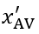,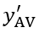) in the local coordinate system

**[7] CF on LC path**

**Description:** When a CAV’s LC is initiated, the CAV will start the CF using linearized ACC model on the generated LC path. The CAV will use linearized ACC model to follow the both preceding vehicles on the current lane (i.e., vehicle 1) and the target lane (i.e., vehicle 2).

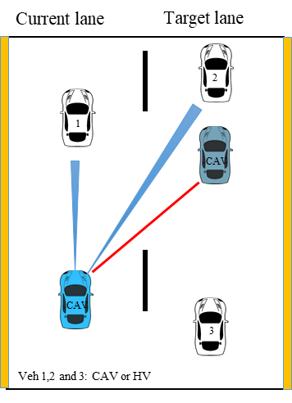

Source: FHWA.

**Formulation:**







**Input:**

*K*1, *K*2: the parameters of the linearized ACC model.

*g*CAV: the desired time gap of CAV.

*C*: the length of the vehicle (CAV and HV).

*x*CAV(*t*): the longitude position of CAV at time *t*.

*v*CAV(*t*): the speed of CAV at time *t*.

*x*1(*t*): the longitude positions of vehicle 1 at time *t*.

*x*2(*t*): the longitude positions of vehicle 2 at time *t*.

*v*1(*t*) and *v*2(*t*): the speeds of vehicle 1 at time *t*.

*v*2(*t*): the speeds of vehicle 2 at time *t*.

**Output:**

*ã*CAV(*t*): the final target acceleration (i.e., the minimum acceleration) of CAV following vehicle 1 and vehicle 2 on the LC path

**[8] LC abortion path**

**Description:** Whenever the safety check fails to pass before the CAV passes the lane marking, the LC will be aborted and a LC abortion path (the green dashed line), symmetric to the LC path, will be generated.



Source: FHWA.

**[9] CF on LC abortion path**

**Description:** When the CAV LC abortion is initiated, the CAV will use linearized ACC model to follow vehicle 1 on the LC abortion path until it goes back to the center line of the current lane.

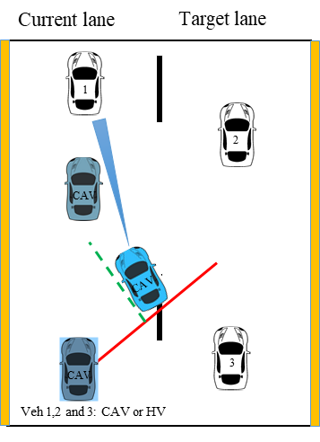

Source: FHWA.

**Formulation:**



**Input:**

*K*1, *K*2: the parameters of the linearized ACC model.

*g*CAV: the desired time gap of CAV.

*C*: the length of vehicle.

*x*CAV(*t*): the longitude position of CAV at time *t*.

*v*CAV(*t*): the speed of CAV at time *t*.

*x*1(*t*): the longitude position of vehicle 1 at time *t*.

*v*1(*t*): the speed of vehicle 1 at time *t*.

**Output:**

*ã*CAV(*t*): the final target acceleration of CAV following only vehicle 1 on the LC abortion path

**[10] Incentive check**

**Description:** The incentive check is only needed for discretionary LCs. The CAV will check and compare the accelerations of following the preceding vehicle on the current lane (i.e., vehicle 1) and the accelerations of following the preceding vehicle on the target lane (i.e., vehicle 2) using linearized ACC model. The incentive check will pass only if the acceleration of the CAV following vehicle 2 is greater than that of the CAV following vehicle 1 by a certain amount.



Source: FHWA.

**Formulation:**







**Input:**

*K*1, *K*2: the parameters of the linearized ACC model

*g*CAV: the desired time gap of CAV

*C*: the length of the vehicle (CAV and HV)

*x*CAV(*t*): the longitude position of CAV at time *t*.

*v*CAV(*t*): the speed of CAV at time *t*.

*x*1(*t*): the longitude positions of vehicle 1 at time *t*.

*x*2(*t*): the longitude positions of vehicle 2 at time *t*.

*v*1(*t*): the speeds of vehicle 1 at time *t*.

*v*2(*t*): the speeds of vehicle 2 at time *t*.

Δ*a*: the changing threshold

*abias*: the asymmetry term with positive value for left turn and negative value for right turn

**Output:**

Whether the incentive check passes or not